|  |
| --- |
|  |
| Ejemplo triggers |
|  |
| *15.Anidados.sql*  *16.Evitar anidados.sql* |

Ejemplo triggers

# Ejemplo

Definimos desencadenadores para realizar el mantenimiento de totales de ventas en diferentes niveles:

1. Insertamos, modificamos o eliminamos de la tabla "Order Details". Esta modificación de datos hace que se ejecute el trigger AFTER UPDATE.

2. EL desencadenador AFTER UPDATE de la tabla "Order Details" actualiza la columna TotalVentas en la tabla Orders.

3. Como la columna TotalVentas en la tabla Orders ha sufrido modificaciones, el trigger AFTER UPDATE definido en la tabla Orders se ejecuta automáticamente y actualiza la columna TotalVentas en las tablas Employees y Customers.

# Tabla: Employees

**Descripción**

Nombres de empleados, títulos y información personal.

|  |  |  |
| --- | --- | --- |
| **Name** | **Type** | **Descripción** |
| Address | Text(60) | Street or post-office box. |
| BirthDate | Date/Time | Employee's date of birth. |
| City | Text(15) | Name of city where employee lives |
| Country | Text(15) | Name of country where employee lives. |
| EmployeeID | AutoNumber | Number automatically assigned to new employee. |
| Extension | Text(4) | Internal telephone extension number. |
| FirstName | Text(10) | First name of employee. |
| HireDate | Date/Time | Date that employee was hired. |
| HomePhone | Text(24) | Phone number includes country code or area code. |
| LastName | Text(20) | Last name of employee. |
| Notes | Memo | General information about employee's background. |
| Photo | Text(255) | Picture of employee. |
| PostalCode | Text(10) | ZIP code where employee lives. |
| Region | Text(15) | State or province |
| ReportsTo | Long Integer | Employee's supervisor. |
| Title | Text(30) | Employee's title. |
| TitleOfCourtesy | Text(25) | Title used in salutations. |

# Order Details

**Descripción**

Detalles de productos, cantidades, y precios de cada pedido de la tabla orders.

|  |  |  |  |  |  |
| --- | --- | --- | --- | --- | --- |
| Column_name | Data type | Nullable | Default | Check | Key/index |
| **OrderID** | **int** | no |  |  | Composite PK, clust1, FK  **Orders**(**OrderID**)2 |
| **ProductID** | **int** | no |  |  | Composite PK, clust1, FK  **Products**(**ProductID**)3 |
| **UnitPrice** | **money** | no | 0 | yes4 |  |
| **Quantity** | **smallint** | no | 1 | yes5 |  |
| **Discount** | **real** | no | 0 |  |  |

# Tabla: Orders

**Description**

Customer name, order date, and freight charge for each order.

|  |  |  |
| --- | --- | --- |
| **Name** | **Tipo** | **Descripción** |
| CustomerID | Text(5) |  |
| EmployeeID | Long Integer | Same entry as in Employees table. |
| Freight | Currency | Shipping cost. |
| OrderDate | Date/Time | Date of order. |
| OrderID | AutoNumber | Unique order number. |
| RequiredDate | Date/Time | Required by date. |
| ShipAddress | Text(60) | Street address only -- no post-office box allowed. |
| ShipCity | Text(15) | Name of city where order was shipped. |
| ShipCountry | Text(15) | Name of country where order was shipped. |
| ShipName | Text(40) | Name of person or company to receive the shipment. |
| ShippedDate | Date/Time | Date that order was shipped. |
| ShipPostalCode | Text(10) | ZIP code where order was shipped. |
| ShipRegion | Text(15) | State or province. |
| ShipVia | Long Integer | Same as Shipper ID in Shippers table. |

# Table: Customers

Nombre, dirección y teléfono de Clientes.

|  |  |  |
| --- | --- | --- |
| **Name** | **Type** | **Description** |
| Address | Text(60) | Street or post-office box. |
| City | Text(15) | Name of city where customer is located. |
| CompanyName | Text(40) | Name of customer company. |
| ContactName | Text(30) | Name of contact person. |
| ContactTitle | Text(30) | Title of contact person. |
| Country | Text(15) | Name of country where customer is located. |
| CustomerID | Text(5) | Unique five-character code based on customer name. |
| Fax | Text(24) | Phone number includes country code or area code. |
| Phone | Text(24) | Phone number includes country code or area code. |
| PostalCode | Text(10) | ZIP code where customer is located. |
| Region | Text(15) | State or province. |



#### Creación del ejemplo

USE Northwind

GO

-- Añadimos la columna VentasTotales a la tabla Orders

ALTER TABLE Orders

ADD VentasTotales money NULL

-- Añadimos la columna VentasTotales a la tabla Employees

LTER TABLE Employees

ADD VentasTotales money NULL

-- Añadimos la columna VentasTotales a la tabla Customers

ALTER TABLE Customers

ADD VentasTotales money NULL

GO

-- Inicializamos los datos

UPDATE Orders

SET VentasTotales =(

SELECT SUM([Order Details].UnitPrice * Quantity * (1 - Discount))

FROM [Order Details]

WHERE [Order Details].OrderID = Orders.OrderID

)

UPDATE Employees

SET VentasTotales =(

SELECT SUM(Orders.VentasTotales)

FROM Orders

WHERE Orders.EmployeeID = Employees.EmployeeID

)

UPDATE Customers

SET VentasTotales =(

SELECT SUM(Orders.VentasTotales)

FROM Orders

WHERE Orders.CustomerID = Customers.CustomerID

)

#### GO

#### Prueba de los datos creados

-- Muestra la información de vetas totales de cada cliente, empleado y pedido

Select CustomerID, VentasTotales from Customers

GO

Select EmployeeID,VentasTotales from Employees

GO

Select OrderID, ventasTotales FROM Orders

#### 

#### Crear trigger para Order details

CREATE TRIGGER TR_TotalOrderDetails

ON [Order details]

AFTER INSERT, DELETE, UPDATE

AS

IF @@rowcount = 1

-- Operación sobre una sola fila

UPDATE Orders

SET VentasTotales = VentasTotales

+ ISNULL(

(SELECT UnitPrice * Quantity * (1 - Discount)

FROM Inserted

WHERE Inserted.OrderID = Orders.OrderID), 0)

- ISNULL(

(SELECT UnitPrice * Quantity * (1 - Discount)

FROM Deleted

WHERE Deleted.OrderID = Orders.OrderID), 0)

ELSE

-- Operación sobre varias filas

UPDATE Orders

SET VentasTotales = VentasTotales

+ ISNULL(

(SELECT SUM(UnitPrice * Quantity * (1 - Discount))

FROM Inserted

WHERE Inserted.OrderID = Orders.OrderID), 0)

- ISNULL(

(SELECT SUM(UnitPrice * Quantity * (1 - Discount))

FROM Deleted

WHERE Deleted.OrderID = Orders.OrderID), 0)

GO

#### Creación de trigger para Orders

CREATE TRIGGER TR_TotalOrders

ON Orders

AFTER INSERT, DELETE, UPDATE

AS

IF @@rowcount = 1

BEGIN

-- Operación sobre una sola fila

UPDATE Employees

SET VentasTotales = VentasTotales

+ ISNULL(

(SELECT VentasTotales

FROM Inserted

WHERE Inserted.EmployeeID = Employees.EmployeeID), 0)

- ISNULL(

(SELECT VentasTotales

FROM Deleted

WHERE Deleted.EmployeeID = Employees.EmployeeID), 0)

UPDATE Customers

SET VentasTotales = VentasTotales

+ ISNULL(

(SELECT VentasTotales

FROM Inserted

WHERE Inserted.CustomerID = Customers.CustomerID), 0)

- ISNULL(

(SELECT VentasTotales

FROM Deleted

WHERE Deleted.CustomerID = Customers.CustomerID), 0)

END

ELSE

BEGIN

-- Operación sobre varias filas

UPDATE Employees

SET VentasTotales = VentasTotales

+ ISNULL(

(SELECT SUM(VentasTotales)

FROM Inserted

WHERE Inserted.EmployeeID = Employees.EmployeeID), 0)

- ISNULL(

(SELECT SUM(VentasTotales)

FROM Deleted

WHERE Deleted.EmployeeID = Employees.EmployeeID), 0)

UPDATE Customers

SET VentasTotales = VentasTotales

+ ISNULL(

(SELECT SUM(VentasTotales)

FROM Inserted

WHERE Inserted.CustomerID = Customers.CustomerID), 0)

- ISNULL(

(SELECT SUM(VentasTotales)

FROM Deleted

WHERE Deleted.CustomerID = Customers.CustomerID), 0)

END

#### Test de triggers

Vamos a realizar una actualización del pedido 10248. Este pedido corresponde al empleado número 5 y al cliente VNET. Por lo que con la actualización del pedido se deverian actualizar Los totales del pedido de la tabla orders. Los totales del empleado y los totales del Clliente.

Vemos la información que tenmos antes de realizar los cambios:

SELECT CustomerID

, EmployeeID

, VentasTotales

FROM orders

WHERE OrderID = 10248

SELECT SUM([Order Details].UnitPrice * Quantity * (1 - Discount))

FROM [Order Details]

WHERE OrderID = 10248

-- Comprobamos los totales en la tabla Employees

SELECT VentasTotales

FROM Employees

WHERE EmployeeID = 5

SELECT SUM(VentasTotales)

FROM Orders

WHERE EmployeeID = 5

-- Comprobamos los totales en la tabla Customers

SELECT VentasTotales

FROM Customers

WHERE CustomerID = 'VINET'

SELECT SUM(VentasTotales)

FROM Orders

WHERE CustomerID = 'VINET'

GO

Resultado:

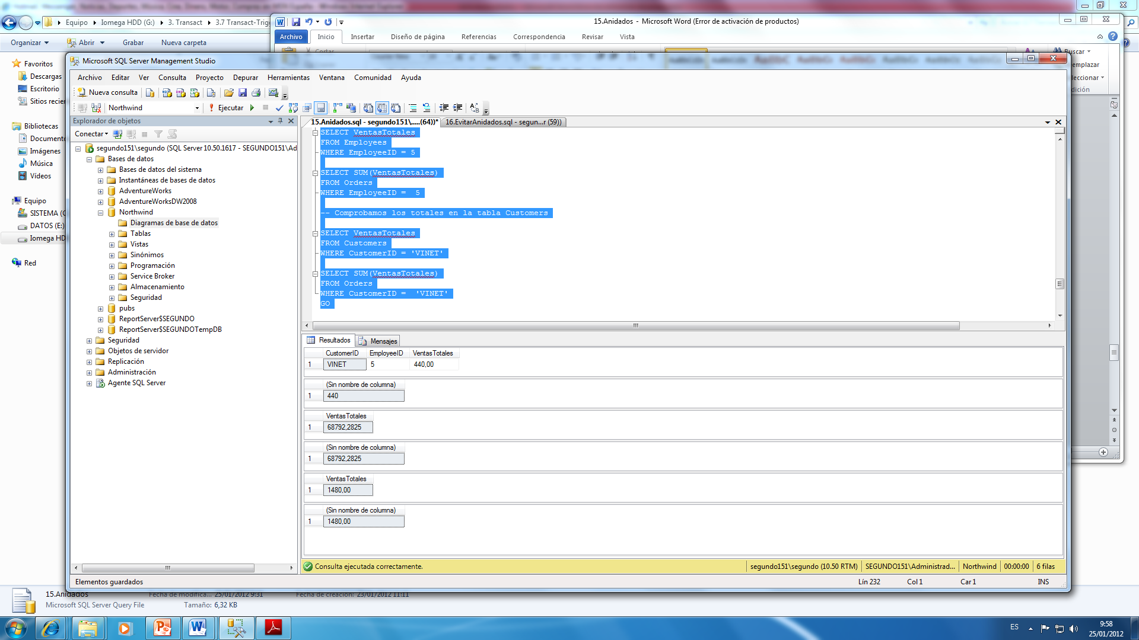

Realizamos la actualización:

UPDATE [Order Details]

SET quantity = 100

WHERE orderid = 10248

AND productid = 11

Volvemos a ver los datos:

SELECT CustomerID

, EmployeeID

, VentasTotales

FROM orders

WHERE OrderID = 10248

SELECT SUM([Order Details].UnitPrice * Quantity * (1 - Discount))

FROM [Order Details]

WHERE OrderID = 10248

-- Comprobamos los totales en la tabla Employees

SELECT VentasTotales

FROM Employees

WHERE EmployeeID = 5

SELECT SUM(VentasTotales)

FROM Orders

WHERE EmployeeID = 5

-- Comprobamos los totales en la tabla Customers

SELECT VentasTotales

FROM Customers

WHERE CustomerID = 'VINET'

SELECT SUM(VentasTotales)

FROM Orders

WHERE CustomerID = 'VINET'

GO

#### Deshacer el ejemplo:

DROP TRIGGER isrTotalOrderDetails

DROP TRIGGER isrTotalOrders

UPDATE [Order Details]

SET quantity = 12

WHERE orderid = 10248

AND productid = 11

ALTER TABLE Orders

DROP VentasTotales

-- Añadimos la columna VentasTotales a la tabla Employees

ALTER TABLE Employees

DROP VentasTotales

-- Añadimos la columna VentasTotales a la tabla Customers

ALTER TABLE Customers

DROP VentasTotales

GO

# Ejemplo2

#### EVITAR TRIGGERS ANIDADOS

Deberíamos evitar el uso de los triggers anidados. Es más recomendable crear un trigger para cada acción lógica. Cada tabla puede tener varios triggers para cada acción.

Nota:

Los ejemplos del Tema 15. y 16. crean un único trigger para tres acciones (INSERT, UPDATE Y DELETE).

En términos de rendimiento, es más eficiente crear triggers individuales para cada acción.

#### Crear trigger para Order details

USE Northwind

GO

CREATE TRIGGER tr_OrderDetails_TotalOrders

ON [Order details]

AFTER INSERT, DELETE, UPDATE

AS

IF @@rowcount = 1

-- Operación sobre una sola fila

UPDATE Orders

SET VentasTotales = VentasTotales

+ ISNULL(

(SELECT UnitPrice * Quantity * (1 - Discount)

FROM Inserted

WHERE Inserted.OrderID = Orders.OrderID), 0)

- ISNULL(

(SELECT UnitPrice * Quantity * (1 - Discount)

FROM Deleted

WHERE Deleted.OrderID = Orders.OrderID), 0)

ELSE

-- Operación sobre varias filas

UPDATE Orders

SET VentasTotales = VentasTotales

+ ISNULL(

(SELECT SUM(UnitPrice * Quantity * (1 - Discount))

FROM Inserted

WHERE Inserted.OrderID = Orders.OrderID), 0)

- ISNULL(

(SELECT SUM(UnitPrice * Quantity * (1 - Discount))

FROM Deleted

WHERE Deleted.OrderID = Orders.OrderID), 0)

GO

CREATE TRIGGER tr_OrderDetails_TotalEmployees

ON [Order details]

AFTER INSERT, DELETE, UPDATE

AS

IF @@rowcount = 1

-- Operación sobre una sola fila

UPDATE Employees

SET VentasTotales = VentasTotales

+ ISNULL(

(SELECT UnitPrice * Quantity * (1 - Discount)

FROM Inserted

JOIN Orders

ON Inserted.OrderID = Orders.OrderID

WHERE Orders.EmployeeID = Employees.EmployeeID), 0)

- ISNULL(

(SELECT UnitPrice * Quantity * (1 - Discount)

FROM Deleted

JOIN Orders

ON Deleted.OrderID = Orders.OrderID

WHERE Orders.EmployeeID = Employees.EmployeeID), 0)

ELSE

-- Operación sobre varias filas

UPDATE Employees

SET VentasTotales = VentasTotales

+ ISNULL(

(SELECT SUM(UnitPrice * Quantity * (1 - Discount))

FROM Inserted

JOIN Orders

ON Inserted.OrderID = Orders.OrderID

WHERE Orders.EmployeeID = Employees.EmployeeID), 0)

- ISNULL(

(SELECT SUM(UnitPrice * Quantity * (1 - Discount))

FROM Deleted

JOIN Orders

ON Deleted.OrderID = Orders.OrderID

WHERE Orders.EmployeeID = Employees.EmployeeID), 0)

GO

CREATE TRIGGER tr_OrderDetails_TotalCustomers

ON [Order details]

AFTER INSERT, DELETE, UPDATE

AS

IF @@rowcount = 1

-- Operación sobre una sola fila

UPDATE Customers

SET VentasTotales = VentasTotales

+ ISNULL(

(SELECT UnitPrice * Quantity * (1 - Discount)

FROM Inserted

JOIN Orders

ON Inserted.OrderID = Orders.OrderID

WHERE Orders.CustomerID = Customers.CustomerID), 0)

- ISNULL(

(SELECT UnitPrice * Quantity * (1 - Discount)

FROM Deleted

JOIN Orders

ON Deleted.OrderID = Orders.OrderID

WHERE Orders.CustomerID = Customers.CustomerID), 0)

ELSE

-- Operación sobre varias filas

UPDATE Customers

SET VentasTotales = VentasTotales

+ ISNULL(

(SELECT SUM(UnitPrice * Quantity * (1 - Discount))

FROM Inserted

JOIN Orders

ON Inserted.OrderID = Orders.OrderID

WHERE Orders.CustomerID = Customers.CustomerID), 0)

- ISNULL(

(SELECT SUM(UnitPrice * Quantity * (1 - Discount))

FROM Deleted

JOIN Orders

ON Deleted.OrderID = Orders.OrderID

WHERE Orders.CustomerID = Customers.CustomerID), 0)

GO

DROP TRIGGER tr_OrderDetails_TotalOrders

DROP TRIGGER tr_OrderDetails_TotalCustomers

DROP TRIGGER tr_OrderDetails_TotalEmployees

GO

# Más información

|  |  |
| --- | --- |
| C/ Miracruz, 10 (Bº de Gros) 20001 Donostia  Telf.: 943 275819  email: [seim@centroseim.com](mailto:seim@centroseim.com) |  |

Logotipo SEIM